

Semester 1 Examination, 2016

Question/Answer Booklet

MATHEMATICS
METHODS
UNIT 3

Section One:

Calculator-free

Student Number: In figures

In words

Your name

Time allowed for this section
Reading time before commencing work: five minutes
Working time for section: fifty minutes

Materials required/recommended for this section
To be provided by the supervisor
This Question/Answer Booklet
Formula Sheet

To be provided by the candidate
Standard items: pens (blue/black preferred), pencils (including coloured), sharpener, correction fluid/tape, eraser, ruler, highlighters

Special items: nil

Important note to candidates
No other items may be taken into the examination room. It is your responsibility to ensure that you do not have any unauthorised notes or other items of a non-personal nature in the examination room. If you have any unauthorised material with you, hand it to the supervisor before reading any further.

Structure of this paper

Section | Number of questions available | Number of questions to be answered | Working  time (minutes) | Marks available | Percentage of exam
Section One:  Calculator-free | 8 | 8 | 50 | 48 | 35
Section Two:  Calculator-assumed | 13 | 13 | 100 | 101 | 65
 |  |  | Total | 149 | 100

Instructions to candidates

- The rules for the conduct of Western Australian external examinations are detailed in the Year 12 Information Handbook 2016. Sitting this examination implies that you agree to abide by these rules.

- Write your answers in this Question/Answer Booklet.

- You must be careful to confine your response to the specific question asked and to follow any instructions that are specified to a particular question.

- Spare pages are included at the end of this booklet. They can be used for planning your responses and/or as additional space if required to continue an answer.
- Planning: If you use the spare pages for planning, indicate this clearly at the top of the page.
- Continuing an answer: If you need to use the space to continue an answer, indicate in the original answer space where the answer is continued, i.e. give the page number. Fill in the number of the question that you are continuing to answer at the top of the page.

- Show all your working clearly. Your working should be in sufficient detail to allow your answers to be checked readily and for marks to be awarded for reasoning. Incorrect answers given without supporting reasoning cannot be allocated any marks. For any question or part question worth more than two marks, valid working or justification is required to receive full marks. If you repeat any question, ensure that you cancel the answer you do not wish to have marked.

- It is recommended that you do not use pencil, except in diagrams.

- The Formula Sheet is not to be handed in with your Question/Answer Booklet.

Section One: Calculator-free 35% (48 Marks)
This section has eight (8) questions. Answer all questions. Write your answers in the spaces provided.

Working time for this section is 50 minutes.

Question 1 (5 marks)
Part of the graph of is shown in the diagrams below.

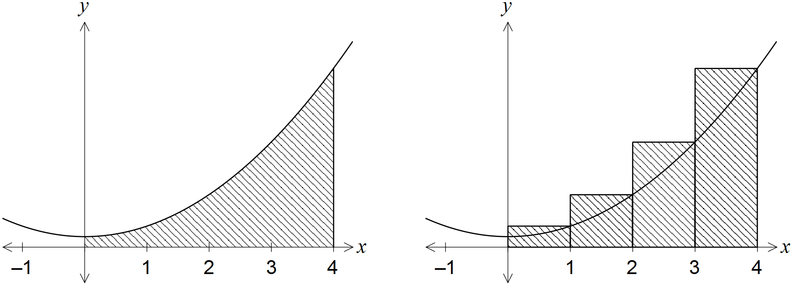

An approximation for the area beneath the curve between and is made using rectangles as shown in the right-hand diagram. Determine the exact amount by which the approximate area exceeds the exact area.

Question 2 (9 marks)
(a) Differentiate the following with respect to x, simplifying your answers.

(i) . (2 marks)

(ii) . (3 marks)

(b) Determine the values of the constants a, b and c, given that when . (4 marks)

Question 3 (6 marks)
A function is such that , where a is a constant and the graph of has a stationary point at (4, 8). Determine .

Question 4 (7 marks)
Consider the function defined by , .

(a) Determine the coordinates of the stationary point of . (3 marks)

(b) Use the second derivative test to determine the nature of the stationary point found in (a). (3 marks)

(c) State the global minimum of . (1 mark)

Question 5 (5 marks)
The area of a segment with central angle in a circle of radius r is given by . Use the increments formula to approximate the increase in area of a segment in a circle of radius 10 cm as the central angle increases from to .

Question 6 (5 marks)
(a) Differentiate , simplifying your answer. (3 marks)

(b) Evaluate . (2 marks)

Question 7 (6 marks)
The discrete random variable X has the probability distribution shown in the table below.

 | 0 | 1 | 2 | 3

Determine the value of the constant a.

Question 8 (5 marks)
The area bounded by the curve and the lines , and is exactly square units. Determine the value of the constant k, given that .

Additional working space

Question number: _________

STUDENT NAME: _____________________________________

MARKING GRID Section One

QUESTION | MARKS AVAILABLE | MARKS ACHIEVED
1 | 5
2 | 9
3 | 6
4 | 7
5 | 5
6 | 5
7 | 6
8 | 5
Section 1 Total | / 48

